Author¹  Author² | ORCID: ..............................  ORCID: ..............................
¹ The Jacob of Paradies University
Faculty of Technology, Department of Manufacturing Engineering
ul. Fryderyka Chopina 52, 66-400 Gorzów Wielkopolski
email:........................

² Affiliation........................................................................
Department............................................................
Address..............................................................
E-mails:........................................................................

The title of the article should be no more than 10 words,
maximum of three lines and centered
(14 points, bold, Times New Roman font)

Summary
Each article should contain a summary briefly describing the most important aspects discussed in it. Abstract font height – 11pt. Times New Roman. First row 1 cm, interlig 1.5. The abstract text should not contain more than 1000-2000 characters (including spaces). The abstract should only reflect what appears in the original article. The word Abstract should be written in bold (12 points)

Keywords: after the executive summary, we put the keywords

1. Introduction
The prepared work should be submitted in electronic form. The paper should be about 10-12 pages long, while maintaining the structure of the text: summary, introduction, 2-4 subheadings, conclusion. A4 page size, 2.5 cm margin settings on each side. The entire work should be written in Times New Roman font 12 pt. Topic titles and subheadings, font size: 14 pt. Line spacing at 1.5. Justified text. Page numbering – Times New Roman 10 pts. with external alignment.
The tables shall be presented as shown in Tab.1, leaving one line of space above and below them at the end. They should be typed in the text and discussed. Do not place the table on the first page of the article. Table captions should have a stand-alone caption and be justified to the center, in Times New Roman 11 pt. font and using italics. Tables should end and start on a single page.

Tab. 1. All tables are numbered in Arabic numerals. The title of the table should be placed in the
above the table, Times New Roman font 11 pts, italics.
World/Poland | Casting alloys | Production in tonnes |  | Participation in global production |  | Share in domestic production
 |  | 2001 | 2018 | 2001 | 2018 | 2001 | 2018
Total World | grey cast iron | 37 194 171 | 49 442 582 | 54,4% | 43,9% | --- | ---
 | ductile iron | 13 279 921 | 28 128 422 | 19,4% | 25,0% | --- | ---
 | malleable cast iron | 1 007 472 | 761 255 | 1,5% | 0,7% | --- | ---

Drawings, graphs should be presented as in Figure 1. They should be legible, leaving one line of space above and below them at the end. Each illustration and photo must be numbered and captioned. Captions under the drawings in Times New Roman font 11 pt., italics (Fig. 1). All descriptions in drawings must be clear and legible. Illustrative material should be attached separately in TIFF or JPEG format (PHOTOS SHOULD NOT BE "TYPED" INTO THE TEXT IN THE WORD FILE!). Charts in black and white. Avoid using thick, black, and/or colored bold letters, as they will look dark when printed. They must also be placed close to the first reference to them in the text and numbered consecutively. The drawing caption should be placed directly below the drawings. Photographs and drawings should be made in the colour of min. 300 dpi resolution.
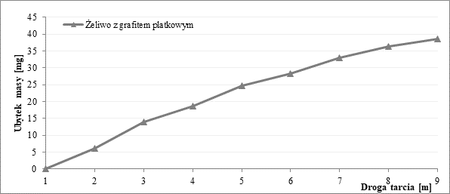
Fig. 1. Each illustration and photo must be numbered and captioned [1]

The numbering of the formulas shall be placed on the right edge of the column in round brackets, e.g. (1). When referring to the numbering of patterns in the text, it should be written in round brackets, as in the case of patterns.

$${\left(x+a\right)}^{n}=\sum_{k=0}^{n}{\left({n \atop k}\right)x^{k}a^{n-k}}$$

A complete bibliography in the order of citation is placed at the end of the publication, and citations in the text should be placed in square brackets.

Bibliography
- Perec A., Multiple Response Optimization of Abrasive Water Jet Cutting Process using Response Surface Methodology (RSM), „Procedia Computer Science„ 2021, nr 192, s. 931–940. DOI: 10.1016/j.procs.2021.08.096.
- Bakhtin M., The Problems of Dostoyevsky's Poetics, Warsaw 1970.

At the end of the paper: the title of the paper, the abstract and keywords in Polish (formatting such as the title and abstract).

